**An Approach for Crop Prediction in Agriculture: Integrating Genetic Algorithms and Machine Learning**

**ABSTRACT: -**

The agricultural sector in many South Asian countries, including Bangladesh and India, plays a pivotal role in the economy, with a significant portion of the population relying on it for their livelihood. However, farmers face challenges like unpredictable weather, soil variability, and natural disasters such as floods and erosion, leading to crop losses and financial difficulties. This often results in a decline in interest in agriculture despite government support. Our study focuses on predicting the classification of various crops, such as rice, jute, and maize, using a combination of soil and weather features. The predictive model leverages soil parameters like Nitrogen, Phosphorus, Potassium, and pH levels, alongside weather variables such as Temperature, Humidity, and Rainfall. We propose a hybrid approach that integrates machine learning with genetic algorithms, where a Random Forest Classifier is used for crop classification across 22 different crop types. The Genetic Algorithm is utilized to optimize hyperparameters, enhancing model performance and robustness. Additionally, we applied Explainable AI (XAI) techniques, including Local Interpretable Model-agnostic Explanations (LIME) and SHapley Additive exPlanations (SHAP), to interpret and validate the model’s predictions. By improving feature selection and model parameters, our approach addresses limitations associated with existing models, providing more reliable and accurate predictions. This system has the potential to reduce crop losses, improve agricultural productivity, and contribute to the sustainability and prosperity of the agricultural sector.

|  |  |
| --- | --- |
| **EXSISTING SYSTEM** | **PROPOSED SYSTEM** |
| * In the realm of agricultural research, numerous existing algorithms have been applied to address crop classification and prediction challenges, especially in regions like South Asia, where agriculture significantly impacts the economy and livelihoods. Traditional approaches such as Decision Tree Classifier, Support Vector Machine (SVM), Naive Bayes, and K-Nearest Neighbors (KNN) have been widely used to predict crop types based on various features like soil composition, weather conditions, and other environmental factors. These algorithms, while effective to some extent, often face limitations in terms of scalability, accuracy, and interpretability, particularly when dealing with large, complex datasets or diverse crop types. For instance, models like Decision Trees can easily overfit, while SVMs may struggle with multi-class classification and require intensive computational resources. Additionally, these traditional algorithms may not be flexible enough to adapt to varying soil and climatic conditions, which are crucial in predicting crop yields in diverse agricultural landscapes. * To address these shortcomings, our study proposes an innovative algorithm that combines the strengths of Genetic Algorithms (GAs) with the Random Forest Classifier, aiming to optimize the predictive accuracy and robustness of crop classification. The proposed algorithm leverages a hybrid methodology where the Genetic Algorithm is employed to fine-tune the hyperparameters of the Random Forest model, enhancing its performance in classifying 22 different types of crops such as rice, jute, and maize. By optimizing key parameters like the number of trees, depth, and feature selection, the integration of GAs ensures that the model is not only more accurate but also more adaptable to the variability in soil and weather conditions. Furthermore, to ensure the model’s predictions are transparent and interpretable, we incorporated Explainable AI (XAI) techniques, specifically Local Interpretable Model-agnostic Explanations (LIME) and SHapley Additive exPlanations (SHAP). | * The proposed system in this study aims to address the limitations of traditional crop prediction models by introducing a novel hybrid approach that combines machine learning with genetic optimization techniques, specifically focusing on improving the accuracy and robustness of crop classification. Our system utilizes a **Random Forest Classifier**, a widely recognized ensemble learning method known for its high performance and ability to handle large datasets with multiple features, to classify a diverse range of crops, including rice, jute, maize, and others. However, to enhance the efficiency and predictive capability of this model, we integrate a **Genetic Algorithm (GA)** to optimize its hyperparameters. The Genetic Algorithm, inspired by the principles of natural selection, iteratively searches for the best combination of parameters, such as the number of trees, maximum depth, and feature subsets, to ensure that the Random Forest model achieves optimal performance. This approach allows the model to adapt more effectively to varying soil and climatic conditions, which are crucial factors in agricultural crop prediction. * our proposed system addresses the computational challenges associated with large-scale datasets by employing parallel processing techniques during the model training and GA optimization phases. This ensures that the system remains efficient and scalable, even when applied to extensive agricultural datasets spanning multiple regions and crop types. The innovative integration of Genetic Algorithms with Random Forests, coupled with XAI techniques, sets our system apart from existing models, offering a comprehensive solution that balances high accuracy, interpretability, and computational efficiency. By leveraging this hybrid methodology, the proposed system aims to provide a reliable decision support tool for farmers, agronomists, and policymakers, helping to mitigate the risks of crop failures due to unpredictable weather patterns, soil variability, and other environmental factors. Ultimately, this system has the potential to enhance agricultural productivity, support sustainable farming practices, and contribute to the economic resilience of farming communities, thereby promoting long-term food security and sustainability in regions heavily dependent on agriculture. |
| **EXISTING ALGORITHM**   * Random Forest Classifier, Decision Tree Classifier, Support Vector Machine (SVM), K-Nearest Neighbors (KNN), and Naive Bayes with LIME And SHAP. | **PROPOSED ALGORITHM: -**   * Random Forest Classifier with Genetic Algorithm. |
| **ALGORITHM DEFINITION: -**   * In existing crop prediction systems, a variety of machine learning algorithms are commonly used for classifying crops based on features such as soil properties. These algorithms include the **Random Forest Classifier**, **Decision Tree Classifier**, **Support Vector Machine (SVM)**, **K-Nearest Neighbors (KNN)**, and **Naive Bayes**. **Random Forest** is an ensemble learning method that aggregates multiple decision trees to improve accuracy and reduce overfitting. **Decision Trees** make predictions by splitting the data into subsets based on feature values, though they are prone to overfitting. **SVM** is effective in high-dimensional spaces and works well with complex datasets but can be computationally expensive. **KNN** classifies data based on the majority class of neighboring data points, but its performance can degrade with large datasets. **Naive Bayes** applies probabilistic reasoning to classify data, assuming feature independence, though it may not perform well when features are correlated. | **ALGORITHM DEFINITION: -**   * The **proposed system** introduces a novel approach by integrating a **Random Forest Classifier** with a **Genetic Algorithm (GA)** to enhance the accuracy and efficiency of crop classification. The Random Forest Classifier, a robust ensemble learning method, is known for its ability to handle large datasets and complex feature interactions. It operates by constructing multiple decision trees during training and outputs the mode of the classes for classification tasks, thereby reducing overfitting and improving prediction accuracy. However, the performance of Random Forest heavily depends on its hyperparameters, such as the number of trees, maximum depth, minimum samples split, and feature selection, which require careful tuning to achieve optimal results. * The integration of **Random Forest Classifier with Genetic Algorithm** offers a powerful solution for crop classification by optimizing model parameters for higher accuracy and providing explainable insights into feature importance. This system not only improves predictive performance but also contributes to sustainable agricultural practices by supporting data-driven decision-making in crop management. |
| **DRAWBACKS: -**   * Lack of Interpretability * Overfitting and Model Complexity * Scalability and Computation Costs * Feature Dependency and Sensitivity * Difficulty in Handling Missing Data * Limited Adaptability to Changing Conditions Problems. | **ADVANTAGES: -**   * Improved Accuracy and Performance * Enhanced Interpretability with Explainable AI (LIME & SHAP) * Optimized Hyperparameters through Genetic Algorithms * Adaptability to Changing Agricultural Conditions * Reduced Overfitting with Ensemble Learning (Random Forest). |

**SYSTEM ARCHITECTURE:**

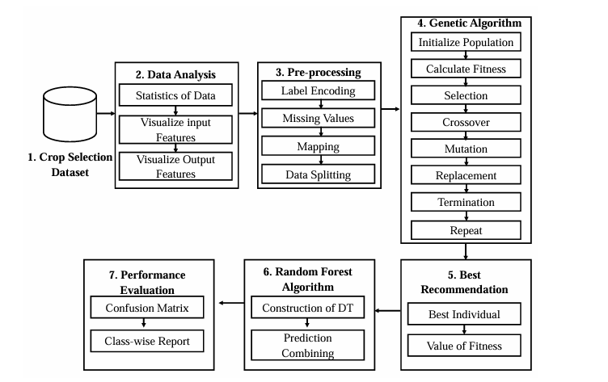

Fig:- proposed model

**MINIMUMSYSTEM REQUIREMENTS**

**HARDWARE REQUIREMENTS**

* PROCESSOR : Pentium i3 Processor
* RAM : 4GB DD RAM
* HARD DISK : 500 GB

**SOFTWARE REQUIREMENTS**

* BACK END : PYTHON
* OPERATING SYSTEM : WINDOWS 10
* IDE : Spyder3